# Introduction

The Switch Adapted Remote Controlled Cartoon Car is an adapted remote controlled car that can be used with two 3.5 mm assistive switches. This adaptation is intended for users that have difficulty activating the small buttons on the remote.

# Research

Some switch adapted cards can be purchased online, either ones designed to be operated by accessible switches or ones that are switch adapted and sold. Often these are expensive, and can also go out of stock. Some examples:

[Switch Adapted Remote Control Race Car](https://switchenabled.com/product/switch-adapted-remote-control-race-car/) –$52 plus taxes and shipping. Two button control.

[Thunder Tumbler Radio Controlled Car](https://www.adaptivetechsolutions.com/pd-switch-adapted-thunder-tumbler-radio-controlled-car/) - $91.11 plus taxes and shipping. Two button control.

[Stunt Car](https://enablingdevices.com/product/stunt-car/) - $170.95 plus taxes and shipping. Joystick control.

# Requirements

## Goals

|  |  |
| --- | --- |
| G01 | Make the toy more accessible by adding the ability to use an assistive switch for operation. |

## Functional Requirements

|  |  |
| --- | --- |
| F01 | The forward and reverse functions are each operated with the use of a 3.5 mm assistive switch. |

## Non-functional Requirement

|  |  |
| --- | --- |
| NF01 | Toy is relatively easy to adapt so that others can do it themselves with our assembly manual. |

## Constraints

|  |  |
| --- | --- |
| C01 | Cost less than $50 so it is less expensive than commercial options. |

# Ideation

This remote-controlled car was chosen to switch adapt because it was readily available, affordable (around $20), and is operated with the use of two buttons, making it easy to switch adapt.

The goal was to add two 3.5 mm jacks in parallel to the original buttons on the remote, so that the forward function and the reverse function can both be operated using assistive switches, but the original buttons will continue to work as well.

Once this was completed, the remote controlled car was tested with multiple assistive switches. When using an assistive switch with a long wire, it was found that the switch would remain on even after being released, until a body part was brought near the antenna. From here it was determined that a 0.01 μF capacitor may need to be installed across each of the switches to help get rid of some of the noise.

The capacitors were installed and tested, and this solved the problem of the switches remaining on. With the capacitors, the adaptive switches worked as expected.

# Detailed Design

The two buttons on the remote were switch adapted using 3.5 mm mono jacks. One button goes forward, and one button reverses and turns. For each switch, the 3.5 mm jack is in parallel to a 0.01 μF (103) ceramic capacitor which are both in parallel with the original switch, as seen below.

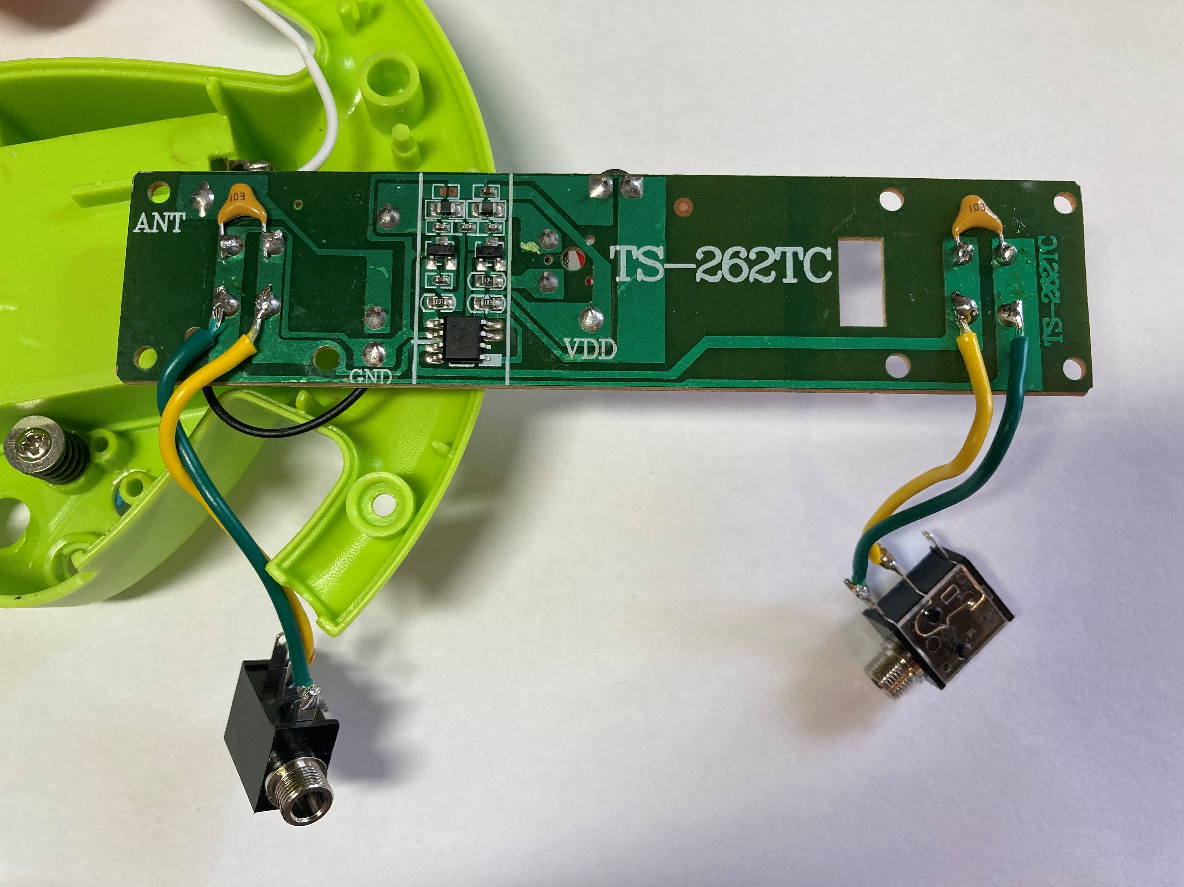

Two holes were then drilled in the remote casing, below the battery compartment. This location was chosen because there is a lot of room for the mono jacks here. The downside of this location is that it needs to be quite precise to both fit the mono jacks but also not interfere with the rotating piece that secures the battery compartment on the other side.

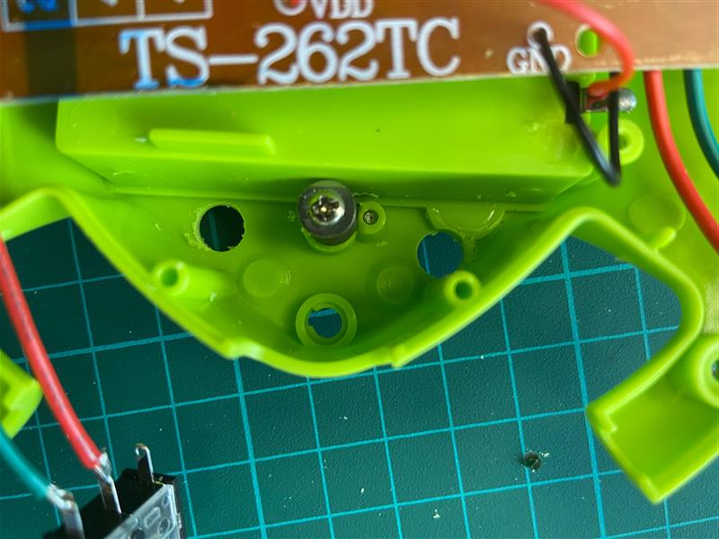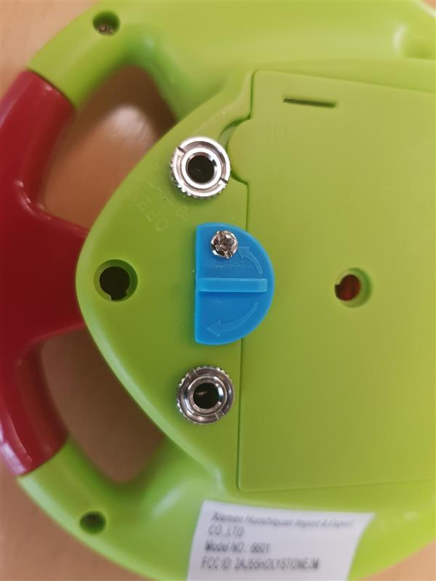

The final design has two mono jacks on the outside to plug in two assistive switches.

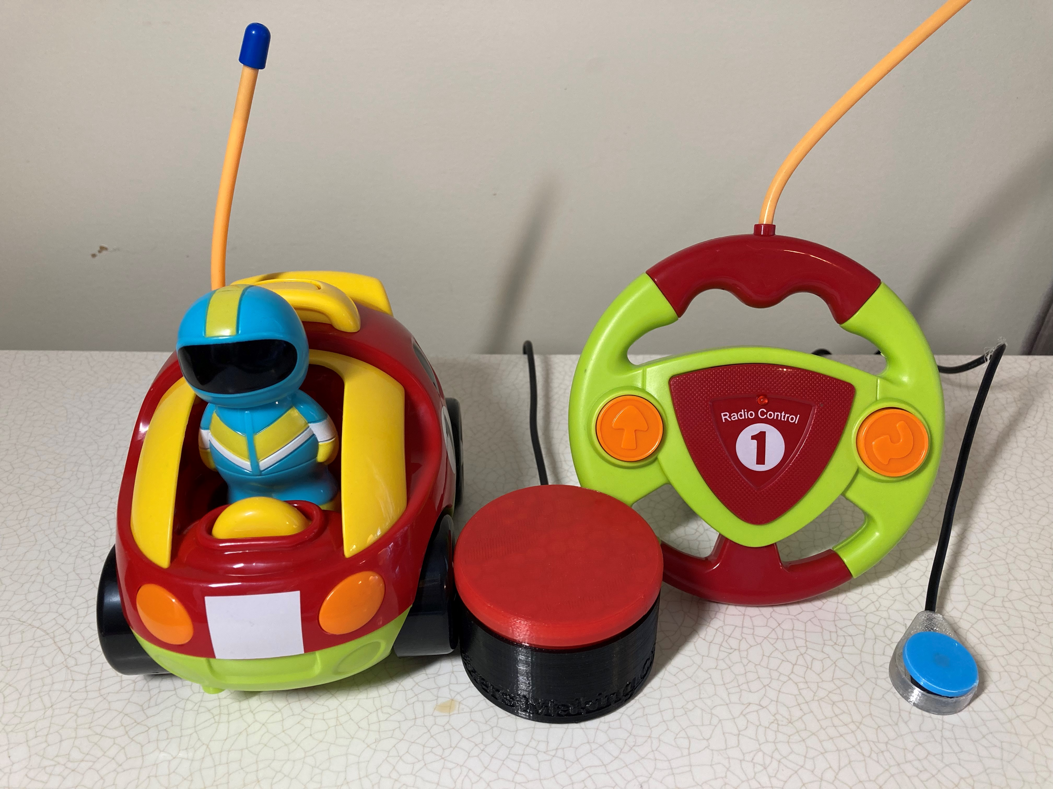

# Opportunities for Improvement

* The location of the drilled holes for the mono jacks has to be quite precise, so that they do not interfere with the rotating blue piece that secures the battery cover. A different location for these mono jacks could make adapting easier.